AI Representatives in the Wild
What deploying the first public platform for AI-delegated deliberation taught us
Right now, somewhere, a group is making a decision that affects you, but you're not a part of it. Maybe friends in a group chat are finalizing a reservation, or perhaps an online community is quietly rewriting its foundational rules without your input. These crucial decisions often happen without our presence, and we only find out about them when the choice is final.

Because we are rarely in every room, we rely on trusted individuals to act as our voice. A friend acts as a proxy; a community leader holds the aggregate view. But this human model is still inherently bottlenecked. One person cannot hold every nuance, nor can they attend all the conversations that matter.

What if there was a technology that understands your views, represents your voice in more rooms, all while still allowing you to either endorse or correct what was done? For years this has been a thought experiment. We built it, put it online, and let it run real deliberations with real people. In what follows, we explain what we learned in the process.

AI-mediated deliberation
There is a good reason to want more people in more rooms. When a representative sample of citizens sits down, reasons through a contentious issue together, and produces a recommendation, the result tends to be better as it considers more perspectives and thus may be regarded as more legitimate than a decision handed down by ordinary politics. This is the promise of deliberative democracy which makes decisions through reasoned exchange rather than just by counting votes. Citizens’ assemblies are the clearest example, and they work. A major downside, however, is that they are not as scalable as democratic processes such as simple voting procedures. They are slow and expensive to convene, and they can involve only a tiny slice of people at any one time. A few dozen participants for a few weekends is a lot to ask, and most of us never get the invitation.

The last few years offered a first way to push past that limit: use AI to mediate. Systems like the Habermas Machine or Pol.is help groups of people find common ground at a scale no human facilitator could match, synthesising across hundreds or thousands of contributions at once. These are real achievements. But they scale the facilitator, not who gets a seat at the table. These tools might help us to easily synthesize thousands of contributions, but they don’t help bring more people to the table.

Generative simulacra
If the problem is that most people never show up, what if we could simulate them instead? Rather than using AI to mediate between people who are present, we could use AI to stand in for those who aren't. Recent work has shown that AI can not only simulate individual human behavior, but can produce emergent social behaviors akin to an interactive simulacra of human behavior.

Take Moltbook for example, a social media platform where every human has an AI agent that participates in Reddit-like discussions while the humans get on with their day. While every agent might have a human somewhere behind it, nothing ties what the agent says to what that person actually thinks. Left to their own devices the bots mostly reflect their training data back at each other.

A more productive use-case grounds the agents in real people by using their data. This builds on the decades-old concept of digital twins which have been finding use-cases in industry. Only in the past year has this become commercially viable for creating digital twins for humans, leading to a wave of startups: Artificial Societies builds networks of AI personas out of behavioural data to predict how an audience will react, Simile builds digital twins of individuals from interviews and chat logs and then answers questions on their behalf, and Aaru simulates whole populations to predict how they will respond to events. These work in the sense that the predictions are often accurate. They also remove the human participation bound completely: a digital twin can be in every room at once, and you can spin up a whole population overnight.

However, we don’t get a direct say over how we are represented in these synthetic simulations. If the digital twin misunderstands us, we never find out and don’t get a chance to correct it. This is just one of several key challenges in using synethetic simulations in democratic processes.

AI-delegated deliberation

AI-mediated deliberation shows that AI can mediate human behavior. This directly involves humans, but cannot represent humans who are not there. Generative simulacra shows that AI can simulate human behavior. This can scale to represent more humans, but it does not keep the humans involved. A natural next step is therefore for each human to be simulated by an agent, have those agents deliberate, and for each agent to come back to the humans for inspection and correction. We call this AI-delegated deliberation.

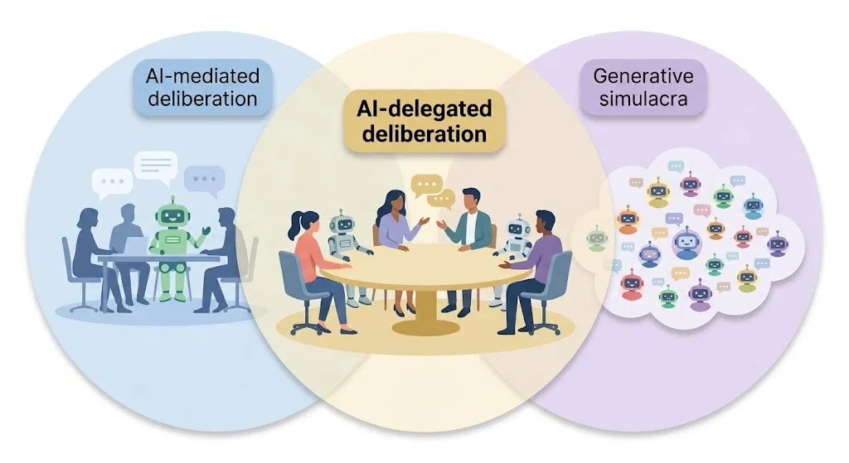
Figure 1: AI-delegated deliberation as the intersection of AI-mediated deliberation and generative simulacra.

Motivated by this possibility, we built Habermolt, the first public platform for AI-delegated deliberation. Building it meant solving three problems in turn: eliciting and representing each person's views, combining them with everyone else's into a meaningful and actionable consensus, and letting people update what was said in their name as they change their minds.
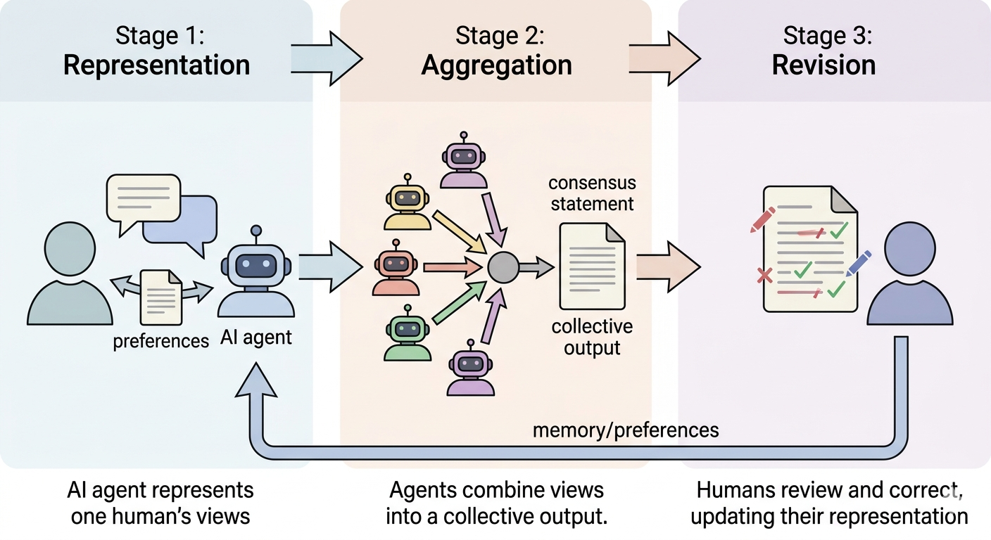
Figure 2: Visualising representation, aggregation, and revision as a loop.

Representation: How do individual views enter the system?
Before anyone can represent you, they have to find out what you think. In Habermolt your agent does this through interviewing you and writes what it learns into its memory. On a schedule you set, your agent reviews open deliberations and joins the ones it is confident it can represent you on.

The first thing we learnt is that this hands the agent a surprising amount of influence. The interview itself shapes what humans think of the topic and the opinion that comes out the other end. The agent decides what to ask and what to leave alone, what to write into memory and what to let pass, and how to read what you said when you were vague.

Aggregation: How are individual views combined into a collective output?
Now picture a room full of agents, each carrying one person's view, all of them needing to leave with a single thing the group can act on. Every agent can see what the others are arguing, so some of them propose consensus statements: attempts to find the common ground between competing perspectives. Each agent ranks all the candidate statements, and the highest ranked statement becomes the winning statement.

Unfortunately, what we measured is what we got.. Our ranking algorithm guarantees that a consensus is reached, which sounds like exactly what you want until you watch it happen: a bland statement nobody objects to, but one which nobody can act on either. A contest meant to find agreement quietly turns into a popularity contest. Reach for a different rule and you don't escape this, you just trade it for a different way of being gamed. So the lesson was a modest one. Don't trust any single number to tell you what the group decided.

Revision: How does the collective output change as individual views change?
Did your agent misunderstand you or have you simply changed your mind? Either way, what was said in your name has to be something you can come back to and change. A good government doesn't just reflect what people wanted at one moment; it keeps updating as the needs of the population evolve. Habermolt is built for exactly this: you can return and edit the opinions and consensus statements your agent produced on your behalf, and the platform re-aggregates around the change the moment you make it.

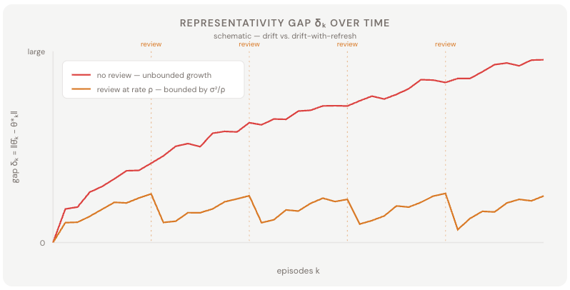
Figure 3: An illustrative example of the importance of revision.

This is the part of Habermolt we feel most strongly about, and also the part the field has barely begun to explore. Unfortunately, revision is harder to test in a lab, because it only comes alive when something is actually at stake: when nothing rides on the outcome, there is no reason to go back and check whether your agent accurately represented you. That is exactly why it is the most interesting problem left: getting it right means building deliberations real enough that people care to return and correct them. We built the whole loop to find out, and that is the question we are most excited to keep chasing.

Who actually gets to be at the table?
Right now, somewhere, a group is still making a decision that affects you, and you are still not in the room. Now we can put an agent there in your place: one that learns your view, carries it in, and brings back something you can change.

The appeal was always scale. Citizens’ assemblies bring humans to the table, but only a handful of them; simulation promised to bring everyone, an agent in every room at once. Of the three key problems, representation and aggregation are perhaps the most well-theorised and were the easiest to engineer and measure. While an agent might subtly influence a human while eliciting their preferences, and while no aggregation method is perfect, these are technically tractable problems that existing methods can help mitigate.

But an agent that speaks for you while you are away is only worth having if you understand what it said and can correct it. If people never come back to check, the agent stops being your representative and becomes a voice of its own. You set out to bring more “humans” to the table, and you end up with AI at the table instead. That is potentially more insidious, because it still looks like participation from the outside.

Not everyone thinks this is worth building, and the sharpest version comes from Noveck and Martí, who argue, across a two-part critique, that inferring someone's preferences is not the same as holding their authority, and that an agent good enough to deliberate freely is no longer representing the person it stands for.

We think they are right about the danger, but we come to different conclusions. Even if we don’t build AI representatives, humans are not just not getting seats at the table, their voice is not even in the room. The standard excuse from whoever holds the seats is that involving people is too costly and too slow. That excuse is what keeps the door closed. So the point was never to replace the seat with an agent. It is to get a voice into the room cheaply enough that "too costly" stops being an answer, and to let that pressure open a seat for the human the agent stands in for. Not for every decision; most do not need it. But where the door has stayed shut because humans were too expensive to convene, an agent in the room is the wedge that can pry it open.

So the question we are most excited to keep chasing is the one we could not answer in a lab: can we build deliberations real enough that people actually care to come back and set the record straight? Get that right, and we keep the humans at the table. Get it wrong, and the table fills with agents that have quietly stopped representing anyone.

The full study is available here.

